**Project**

**Movie Lens - Business Report**

MovieLens is a company in the internet and entertainment domain providing an online database of information related to films, television series, and online streaming content including cast, production crew, trivia, ratings, fan, and critical reviews. Every year in collaboration with a guest curator, MovieLens publish their annual insights based on a theme providing a comprehensive view of a topic. The company is planning to bring out the "Movie Talkies: Classic" edition this year. The idea is to connect with viewers who have strong movie preferences as well as promote classic movies to attract newer customers and expand their viewer base.

**Project Questions:**

**Question 1: How many movies were released until 2000? How many distinct genres have come up till the year 2020?**

**Answer:**

**Creating a card visual to display the Total number of movies released and Total number of distinct Genres separately**

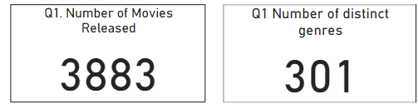

There are in total 3883 movies that were released along with 301 distinct Genres.

**Question 2: How many users are part of the MovieLens community, and what is the gender diversity in this community?**

**Answer:**

**Used a card visual to display the number of users and donut chart to visualize the gender distribution among users.**

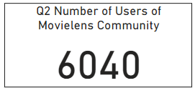 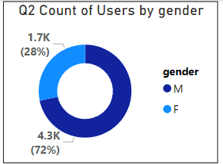

**Question 3: What are the genre preferences of different genders, highlighting user engagement?**

**Answer:**

**Used an area chart to highlight the average ratings across various movie genres based on gender. Create a new genre group that combines similar genres Eg :- Action | Adventure, Action | Thriller are grouped as “Action based” into a group and used these groups to create visualizations.**

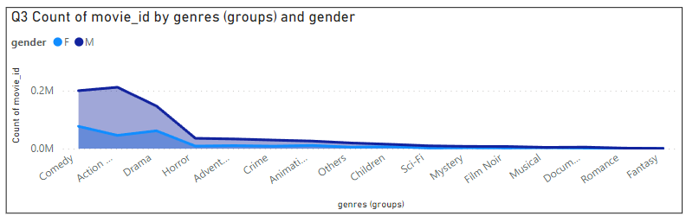

**Question 4: What's the average user rating for classic movies, reflecting overall reception? How does the distribution of movies vary across different genres?**

**Answer:**

**Created gauge chart showing average rating and used bar chart that shows number of movies released across different genre groups. Also created a new measure to calculate average rating and then used this measure in creating visualizations. Years were grouped together to create a new column Decades Eg :- [1940 to 1949] as 1940s and then these decades were used to create a slicer.**

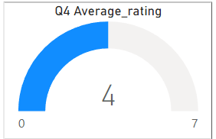

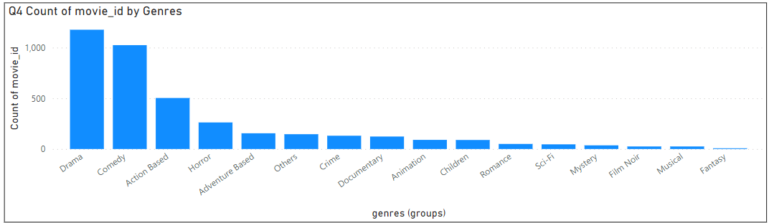

**Question 5: How does the demographic distribution of the users look like across gender? Where do these users live?**

**Answer:**

**I used a column chart to visualize the distribution of users across age groups based on their gender. I used map chart to visualize locations of these users and along with that I used bubbles to indicate the number of users in each locations.**

**Created a new age_group column based on age Eg: “18-24”, “25-34”, “35-44”, etc. and used in further visuals.**  
**Users having age less than 18 were replaced by median age.**

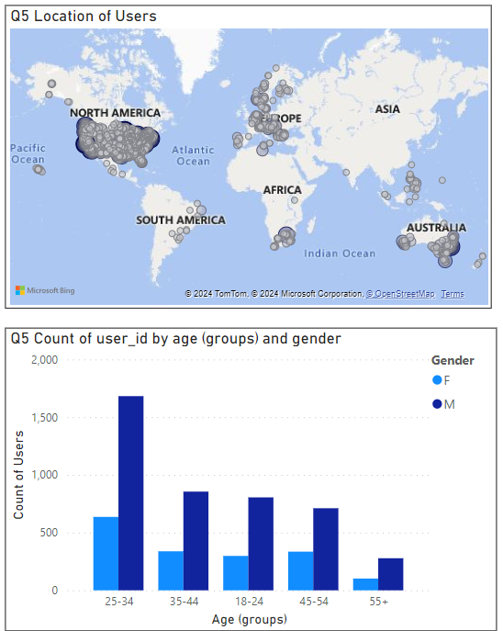

**Question 6: How do users across different age groups and professions engage with classic movies, revealing generational interests?**

**Answer:**

**I used a matrix visual to visualize the average ratings across professions and age groups and used decade and occupations values as slicer.**

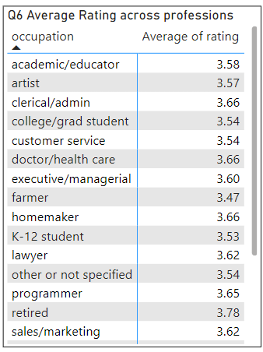

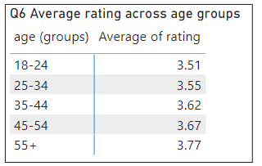

**Question 7: Which classic movies and genres are top-rated? How do these ratings differ based on user age and occupation?**

**Answer:**

**I used tree map to visualize the Top 10 Movies and Genres with Occupation and User Age as slicers**

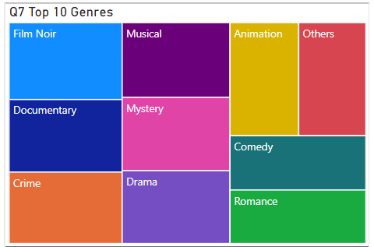

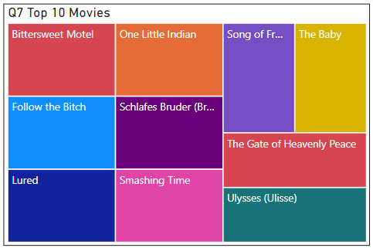

**Question 8: Is there a link between user age and the ratings they provide for classic movies, providing insights into age-related viewing habits? How do the average ratings vary over the years based on the genre considered?**

**Answer:**

**Created a scatterplot between user age group and average rating, with number of users as the size of the bubble. For the second Part I created a line chart that visualizes the average rating of movies across years.**

**Added slicers that help to visualize values based on the decade chosen and genre chosen.**

